Difference between TCP and UDP
1. Full Form
- TCP → Transmission Control Protocol
- UDP → User Datagram Protocol
2. Connection
- TCP: Connection-oriented → needs a connection (handshake) before data transfer.
- UDP: Connectionless → sends data directly, no setup.
3. Reliability
- TCP: Reliable → guarantees delivery, order, and error-checking.
- UDP: Unreliable → no guarantee of delivery, order, or duplication checks.
4. Speed
- TCP: Slower due to acknowledgments, retransmissions, error handling.
- UDP: Faster since it skips those checks.
5. Data Transfer
- TCP: Stream-oriented (continuous flow of data).
- UDP: Message-oriented (sends discrete packets).
6. Use Cases
- TCP: Web browsing (HTTP/HTTPS), Email (SMTP, IMAP, POP3), File transfer (FTP).
- UDP: Video streaming, Voice calls (VoIP), Online gaming, DNS queries → where speed matters more than reliability.
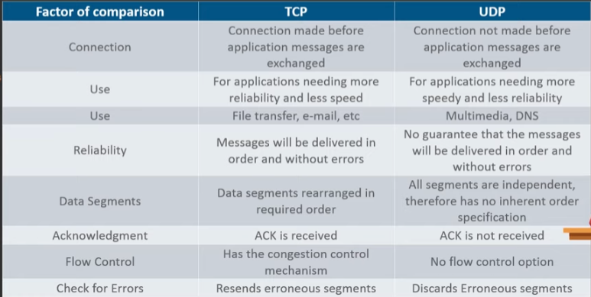

Difference between hub, switch and router
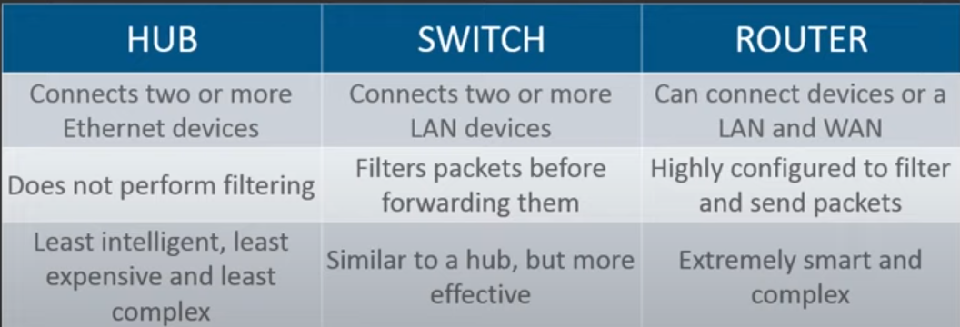
What is a link?
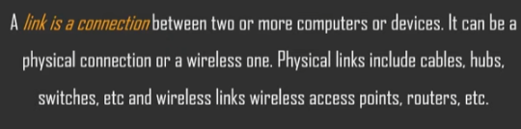
What is a router?
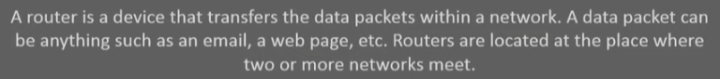
What is OSI Model?
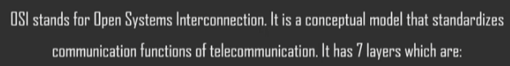
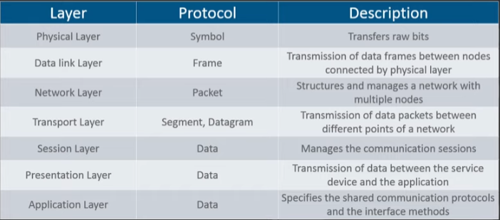

What is a network?
Interconnection of various devices through certain connection media.

What is subnet mask?
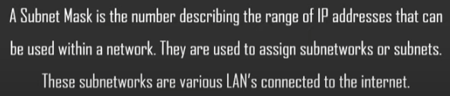
Subnet mask is created by setting all network bits to 1 and all host bits to 0.

What is IP (Internet Protocol)?
- IP = Internet Protocol.
- Responsible for addressing and routing data packets so they can travel across networks.
- Every device on a network gets an IP address (like a phone number for computers).
- Works at the Network Layer (Layer 3) of OSI model

What is TCP (Transmission Control Protocol)?
- TCP = Transmission Control Protocol.
- Works on top of IP → together we call it TCP/IP.
- Provides reliable, ordered, error-checked delivery of data between applications.
- Works at the Transport Layer (Layer 4) of OSI model.

What is HTTP?
- HTTP = HyperText Transfer Protocol.
- It’s an application-layer protocol used for communication between web browsers (clients) and web servers.
- It defines how requests and responses are formatted and transmitted.
- It’s stateless → each request is independent (though cookies/sessions can add state).
Ports Used by HTTP
- HTTP (non-secure): Port 80
- HTTPS (secure, over TLS/SSL): Port 443

Default Ports
Nodejs 3000
Flask 5000
React 3000
Rect with vite 5173

Q. What is RIP?

Q. What is a Firewall?
A firewall is a network security system (hardware, software, or both) that monitors and controls incoming and outgoing network traffic based on predefined security rules.

Q. Full form of ASCII
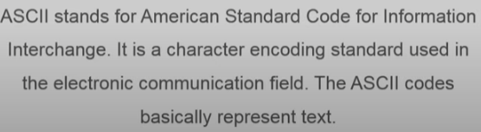
Q. What is a MAC Address?
- MAC = Media Access Control Address.
- It’s a unique hardware identifier assigned to a network interface card (NIC) by the manufacturer.
- Works at the Data Link Layer (Layer 2) of the OSI model.
- Written as 6 pairs of hexadecimal digits (48 bits).

Q. What is DNS?
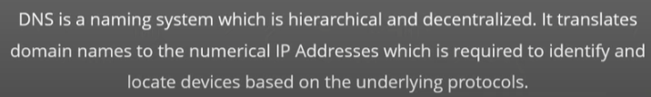

What is DHCP?
- DHCP = Dynamic Host Configuration Protocol
- It’s a network management protocol that automatically assigns IP addresses and other network settings to devices on a network.

What is ping?
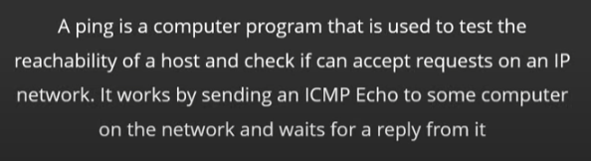

What is Ethernet?
- Ethernet is a wired networking technology used to connect devices in a Local Area Network (LAN).
- It defines standards for cables, connectors, and data transmission so devices can communicate reliably.

What is tunnel mode?
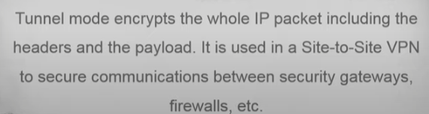

What is IPv6?
It is Internet Protocol Version 6 which uses 128 bits length address
What is a Gateway?
- A gateway is a network device that acts as a bridge between two different networks, often a local network and the internet.
- It routes traffic from devices in one network to another network.
- Usually, a router acts as a gateway in home or office networks.

